

Technical Reference Guide

Table of Contents

Introduction 3

Hardware Configuration 3

Software Configuration 5

Operating System 5

IP Addressing 7

Wi-Fi 8

Remote Access Setup – SSH and Virtual Network Computing 9

GPS 14

Smart Power Switch 16

Aesthetics 17

Change Raspbian Menu Icon 17

Change Raspbian Desktop Graphic 18

Banner Login 18

Cloning SD Card 19

# Introduction

The Homing Activity Wireless Kit (HAWK) is an independent and self-contained device that provides location data of authorized unmanned aerial systems (UAS) operating over restricted airspace. There are multiple key components that make up the HAWK; System on a Chip (SoC) board, Global Position System (GPS), Wireless board (Wi-Fi), PowerBoost, and Lithium Ion Polymer (LiPo) battery.

The purpose of this document is to provide the physical and software configuration of the HAWK.

# Hardware Configuration

This section will cover the various boards and their physical connections to each other within the HAWK.

The HAWK contains multiple components that perform a specific function within the module. The table below outlines each of the major components inside the HAWK:

|  |  |  |  |
| --- | --- | --- | --- |
| **Component** | **Manufacturer** | **Model** | **Function** |
| System on the Chip | Raspberry Pi | Zero | Core computing board |
| Global Positioning System | Adafruit | Ultimate GPS | Captures latitude, longitude, altitude, heading, and velocity information |
| Wireless Card | TBD | TBD | Interface for wireless transmission |
| PowerBoost | Adafruit | PowerBoost 1000C | Boosts 3.7V input to 5.0V |
| LiPo Battery | Adafruit | 3.7V 500mAh | Internal power supply |
| RGB LED Breakout Board | Digi | TBD | Connection point for the RGB LED, resistors, and wiring |
| UFL to SMA Cable (GPS) |  |  | External GPS cable adapter |
| Smart Power Switch |  |  | Multi-function power switch |
| RGB LED |  |  | Multi-color status indicator |
| Micro-AB Female Connector | Amp |  | External power connector port |

The SoC features a 40-pin general purpose input/output (GPIO) interface. Some of the board components uses these GPIO pins to communicate with the SoC. The figure below outlines the GPIO layout by their function, GPIO number, and its associated pin number. Following the figure is a table outlining the board connections to the GPIO pins on the SoC.

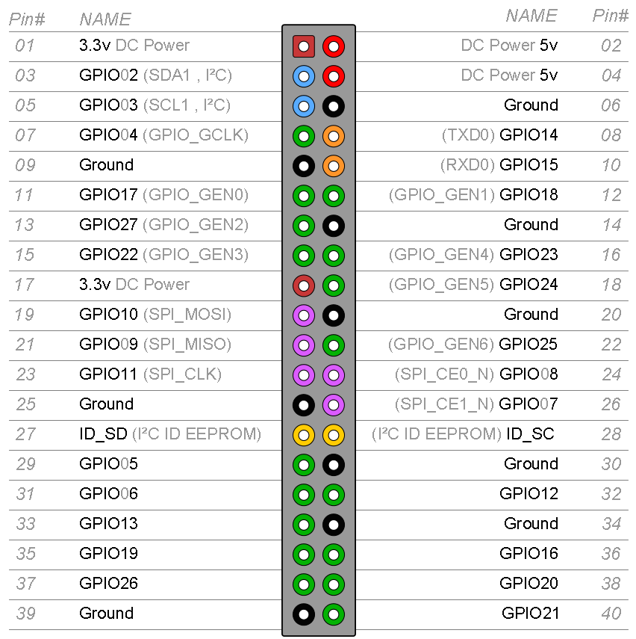

|  |  |  |  |
| --- | --- | --- | --- |
| **Component** | **Component Pin** | **SoC GPIO Pin** | **SoC Pin#** |
| GPS | VIN (voltage in) | DC Power 5V | 04 |
| GND (ground) | Ground | 06 |
| Rx (receive) | GPIO 14 (UART Tx) | 08 |
| Tx (transmit) | GPIO 15 (UART Rx) | 10 |
| Wireless Card | USB Vcc  (pin 1, red wire) | DC Power 5V | 02 |
| USB Ground  (pin 4, black wire) | Ground | 14 |
| Smart Power Switch | In | GPIO21 | 40 |
| Out | GPIO20 | 38 |
| PowerBooster  (Low Battery Output) | LBO | GPIO16 | 36 |

There are various test pads on the bottom of the SoC. Some of these test pads were used to support to some of the boards. The figure below shows some of the test pads. Following the figure is a table that outlines which test pads are being used.

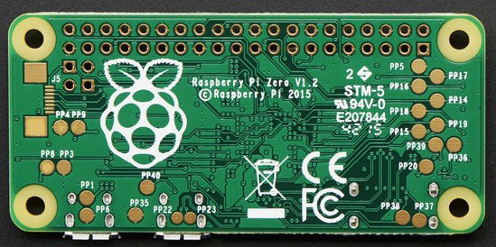

|  |  |  |
| --- | --- | --- |
| **Component** | **Component Pin** | **Test Pad ID** |
| PowerBoost | USB + (3.5mm) | PP1 |
| USB – (3.5mm) | PP6 |
| Wireless Card | USB Data +  (pin 3, green wire) | PP22 |
| USB Data -  (pin 2, white wire) | PP23 |

As shown below, the SoC is using a Broadcom ARMv6 compatible processor (BCM2708).

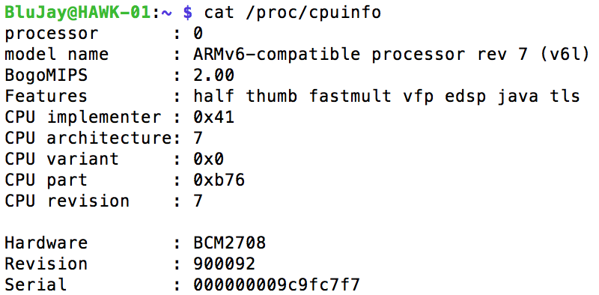

For general deployment of the HAWK, it is expected that the wireless card will be the only component connected the the SoC’s USB data port. For the purpose of setting up the HAWK, a four-port USB hub (Terminus Technology) is used to host a Logitech keyboard with touchpad (via USB Unifying Receiver) and wireless connection (via RT5370 wireless adapter). To see what USB devices are connected to the SoC, type “lsusb” and press enter from the command line on the SoC.

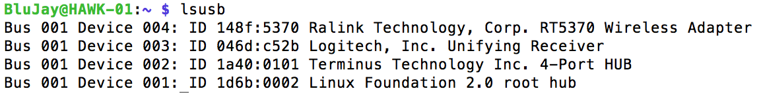

In the event a user wants to confirm the temperature of the CPU on the SoC, type “sudo vcgencmd measure_temp” and press enter. The command will return with the CPU’s temperature in Celsius as shown below.



The HAWK features a multi-function power button that will enable the user to power on and off the module. In conjunction to the button is a lighting emitting diode (LED) that will illuminate different colors depending on the state and condition of the HAWK module.

The power button is designed perform an action based on the state of the module. At a powered down state, pressing and quickly releasing the button will power on the HAWK module. Upon receiving power, the LED will illuminate in blue. When the HAWK connects with the network, the LED will change to green.

There are two options to power down the HAWK module; soft or hard shutdown. Since the SoC is based on Linux, it is recommended that the system undergoes a “graceful” or soft shutdown. To do this, a command or script is issued to the SoC to shutdown after various processes on the processor has halted. While the HAWK is powered on, a soft shutdown is performed with a press and quick release of the power button. If the user has access to the command line, the soft shutdown can be issued by typing “sudo shutdown –h” and pressing enter. The LED will turn red while the HAWK is halting its processes. The LED will turn off when the module is completely powered down. A soft shutdown will take approximately 30-60 seconds.

A hard shutdown can be performed if the user suspects the HAWK is in a locked or unresponsive state. A hard shutdown should only be performed as a last effort. Performing a hard shutdown can run a risk of corrupting the SD card and all its data. To perform a hard shutdown while the HAWK is powered on, press and hold the power button for more than five seconds. The module will immediately power down and the LED will turn off.

Below is a summary of the different actions for the power button and the resulting LED colors.

|  |  |  |
| --- | --- | --- |
| Action | Power Button | LED Color |
| No Power | No Action | Off |
| Power On | Quick Press and Release | Blue |
| Network Connection | No Action | Green |
| Soft Shutdown | Quick Press and Release | Red |
| Hard Shutdown | Press and Hold for 5-Seconds | Off |

# Software Configuration

This section will cover the software configuration HAWK. Majority of the software configuration takes place in the SoC.

## Operating System

The SoC is the core of the HAWK system. The SoC is based a Linux operating system (OS) called Raspbian. This OS is freely available from the Raspberry Pi (RPi) Foundation, based in the United Kingdom (UK).

For ease of installation, Raspbian was loaded onto the SoC by a software installer program called NOOBS. This program is provided by RPi to aid in the installation of their OS for people want ease of loading their OS onto the SoC. With NOOBS loaded on the MicroSD card and inserted into the SoC, the OS will automatically begin the installation process upon powering on the board. After the OS is installed, the user can type “cat /proc/version” to see what version of Linux was installed. Note, this information may vary based on the time and date when NOOBS and the OS was acquired.



Upon completion of the OS installation, the RPi Configuration desktop window was accessed to configure the SoC password, hostname, remote access, system clock, and regional settings.

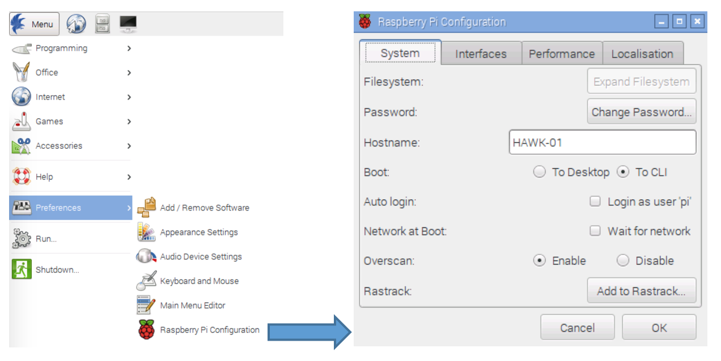

By default, the password to the SoC is “*raspberry*.” For security reasons, the password was changed to “*!BluJ@y!*” as the new default. The username “*BluJay*” was created with the same password “!BluJ@y!” The following steps were taken to create the username and password:

1. From the SoC Terminal window, type “sudo useradd –m BluJay –G sudo” and push enter
2. Next, type “sudo passwd BluJay” and push enter
3. Type in the BluJay password “!BluJ@y!” and type same password again to verify.
4. Sign out of the SoC and login again as BluJay to verify access
5. Next, add the username BluJay to the sudoers file. To do this, type “sudo visudo” and push enter
6. Type at the end of the file “BluJay ALL=(ALL) NOPASSWD: ALL”
7. Press Control-X and press “y” to save the changes. Then, press enter again to save the changes under the same file name

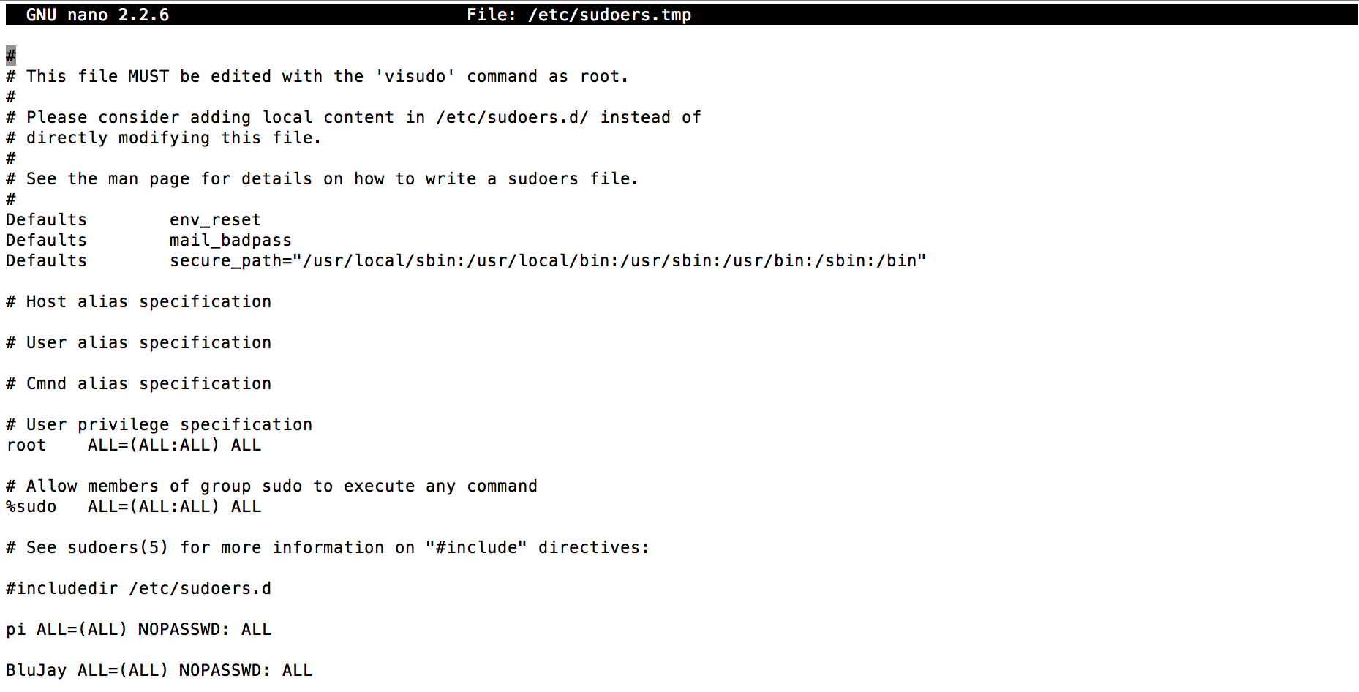

As shown in the figure above, the username “pi” is still populated on the SoC. Although this is a default username for the SoC, the password was changed to match the login for BluJay.

The default hostname of the SoC is “*raspberry*.” The hostname has been changed to “*HAWK-01*.” The number portion of the hostname can change to accommodate for the number of HAWK units used by an organization.

To enable remote access, secure shell or SSH is checked. This will allow users to access the HAWK over a secure IP connection on the same local area network (LAN). The SoC will will support another type of remote access which will be discussed in further detail later in this document

To save on power and increase performance, the SoC has been configured to boot-up into the command line instead of the Desktop GUI. The user can access the desktop GUI by typing “startx” from the command line.

The system clock was configured for Greenwich Mean Time (GMT) as a reference for timekeeping. Regional settings were set to U.S.

## IP Addressing

Internet Protocol (IP) addressing for the HAWK is based on private addressing scheme that identifies the its node identification and the network (NEST) for which it belongs to. For example, the demonstration network NEST-01 with two HAWK modules; HAWK-01 and HAWK-02. The The network for NEST-01 will be represented by the third octet of the IP address block; 10.10.1.X. The forth octet, represented by the letter “X” in the last example, will be based on the number assigned to the HAWK module. In this case, the IP address for HAWK-01 will be 10.10.1.1 and HAWK-02 will be 10.10.1.2.

The IP address range or block will be based on the Classless Inter-Domain Routing (CIDR) method. The CIDR IP block can be modified based on the expected number of nodes on the network. For the demonstration, the IP block will be limited to a total of six (6) IP addresses. This IP block is represented by the subnet mask of 255.255.255.248 or the CIDR notation of /29.

As a part of the NEST-01 ground network, the Outdoor Wireless Link (OWL) will serve as the wireless access point for the HAWK modules. The OWL-01 will have the IP address 10.10.1.6 (this is the last usable IP address in the CIDR block for 10.10.1.0/29).

## Wi-Fi

TBD – Static IP addressing, SSID, and WPA2-PSK

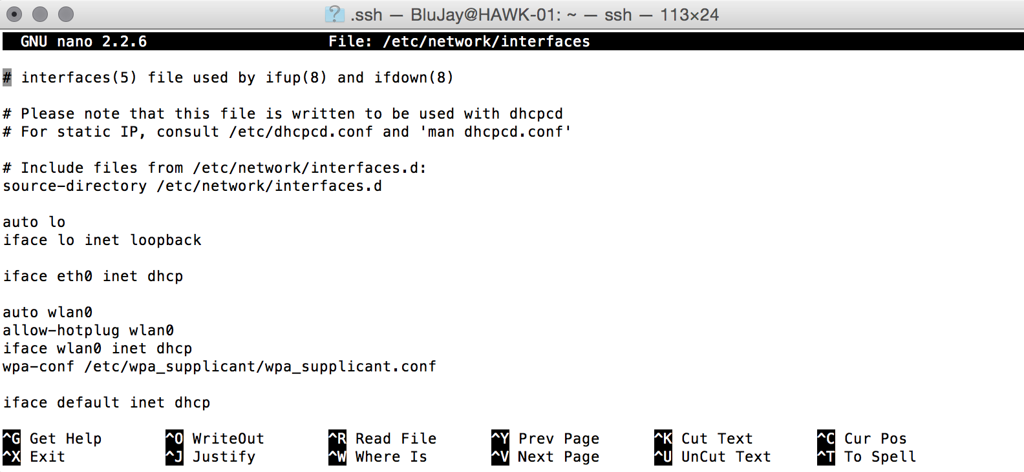

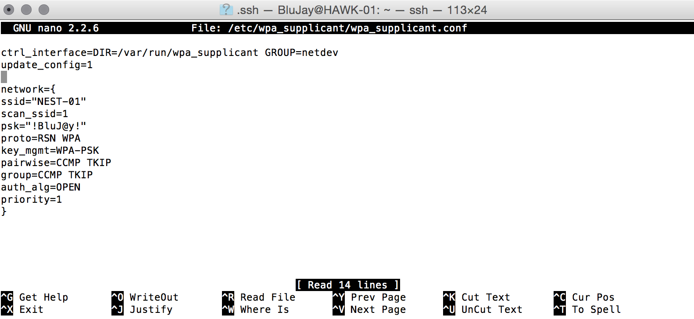

For the purposes of the demonstration, a TP-Link TL-WR702N 802.11N Wireless Nano Router will be acting as the “Outdoor Wireless Link” or OWL as a part of the NEST ground infrastructure. The OWL in this case has a static IP address of 10.10.1.6/29 (subnet mask 255.255.255.248). The OWL is accessible via an Internet browser at <http://10.10.1.6> (or tplinklogin.net). The username is “OWL-01” with the password “BluJay.”

## Remote Access Setup – SSH and Virtual Network Computing

There are several different methods to remotely access the HAWK module. One of these methods is the use of a secure shell (SSH) connection from a SSH Client (i.e. PuTTY for Windows or Terminal for Mac). The use of SSH is limited to the use of commands from the command line. To enable this feature, go to the HAWK Menu, Preferences, and select Raspberry Pi Configuration (same window access earlier).

From the configuration window, go to the Interfaces tab and press the Enable button for SSH. Press the OK button and reboot the HAWK. After the reboot is completed, open a command or terminal window from another computer on the same network as the HAWK. Type “ssh [BluJay@10.10.1.1](mailto:BluJay@10.10.1.1)” and press enter. When prompted, type the password “!BluJ@y!” and press enter. Accept the security key when prompted.

Enabling SSH can be performed from the command line as well. Type “sudo raspi-config” and press enter. From the menu, select Advanced Options and then SSH. Select Enable and press enter.

For a graphical remote connection, the use of Virtual Network Computing (VNC) is recommended. VNC will enable a user to remotely access the HAWK module as if they are physically connected with a keyboard, monitor, and mouse. This section will go over the installation of VNC onto the HAWK module. This procedure will require the HAWK module to be connected to the Internet (see IP addressing and Wi-Fi sections for details).

Log into the HAWK module and access the Terminal window. As depicted in the figure below, enter “sudo apt-get install tightvncserver.” You will be prompted that the application will take up space on the disk. Type “y” to proceed.

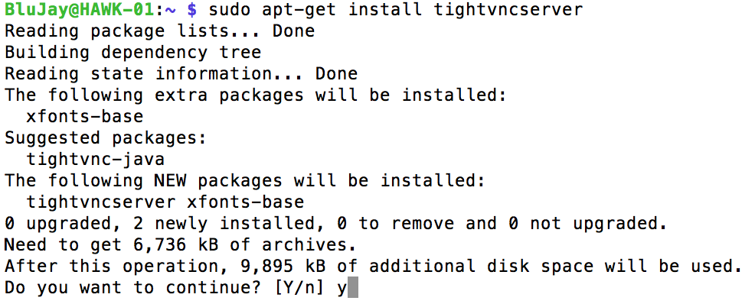

After VNC has installed, type “which tightvncserver” to locate the directory where the application is installed as shown in the figure below. In this case, the application is installed in /usr/bin/tightvncserver. Move to this directory (type “cd /usr/bin” at the command prompt) and launch the application by entering “./tightvncserver.” The application will launch and prompt you for a password. The password has been set as “!BluJ@y!”

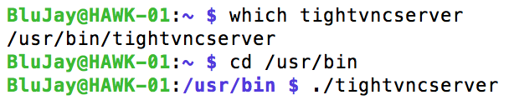

The computer remotely accessing the HAWK will need to have a VNC client application installed. The following VNC clients can be downloaded and installed based on the remote computer’s OS:

**Linux**: It is likely the Linux distribution used comes with a Remote Desktop Viewer application. It can be usually found under Applications/Internet/Remote Desktop Viewer. From the Connect window, choose VNC as the protocol and enter in the IP address or host name of the HAWK module. For the demonstration, enter the HAWK’s IP address is 10.10.1.1:1 or host name HAWK-01:1 (the “:1” following the IP address and host name is the VNC screen being accessed).

**Mac**: Although Mac comes with a Screen Sharing application, the VNC client from RealVNC is simpler to use. Their application can be downloaded from [www.RealVNC.com](http://www.RealVNC.com). During the installation process, ensure VNC Viewer is only selected and uncheck VNC Server as shown below. Click continue to complete the installation process.

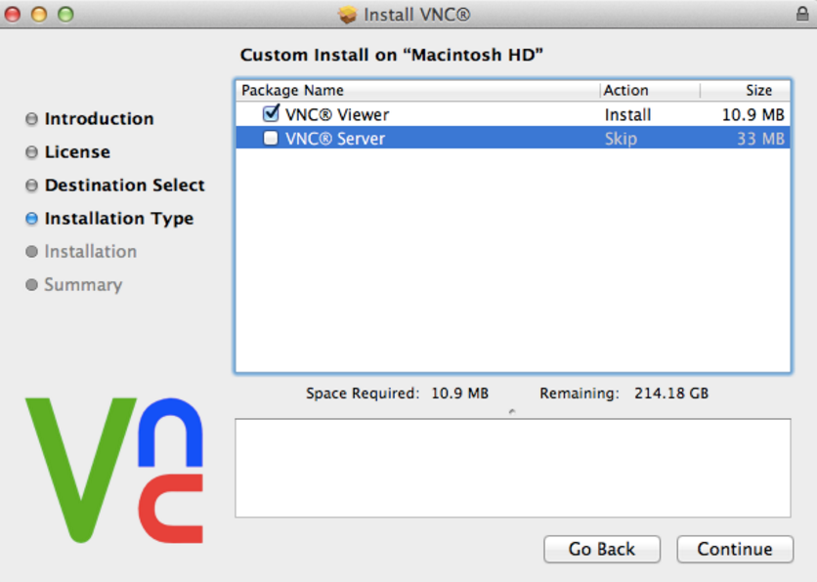

Upon launching the VNC Viewer application, enter in the IP address or host name of the HAWK module as the VNC Server. For the demonstration, enter the HAWK’s IP address is 10.10.1.1:1 or host name HAWK-01:1 (the “:1” following the IP address and host name is the VNC screen being accessed). An “Unencrypted Connection” warning window will appear. Click Continue to proceed.

**Windows**: The VNC client application can be downloaded from [www.tightvnc.com](http://www.tightvnc.com). Depending on OS being used, download either the 32-bit or 64-bit version. During the installation process, select Custom installation and mark the TightVNC Server as “Entire feature will be unavailable.” By doing this, only the VNC Client application will be installed. Click Next and uncheck the Windows Firewall option and then click Next to complete the installation process.

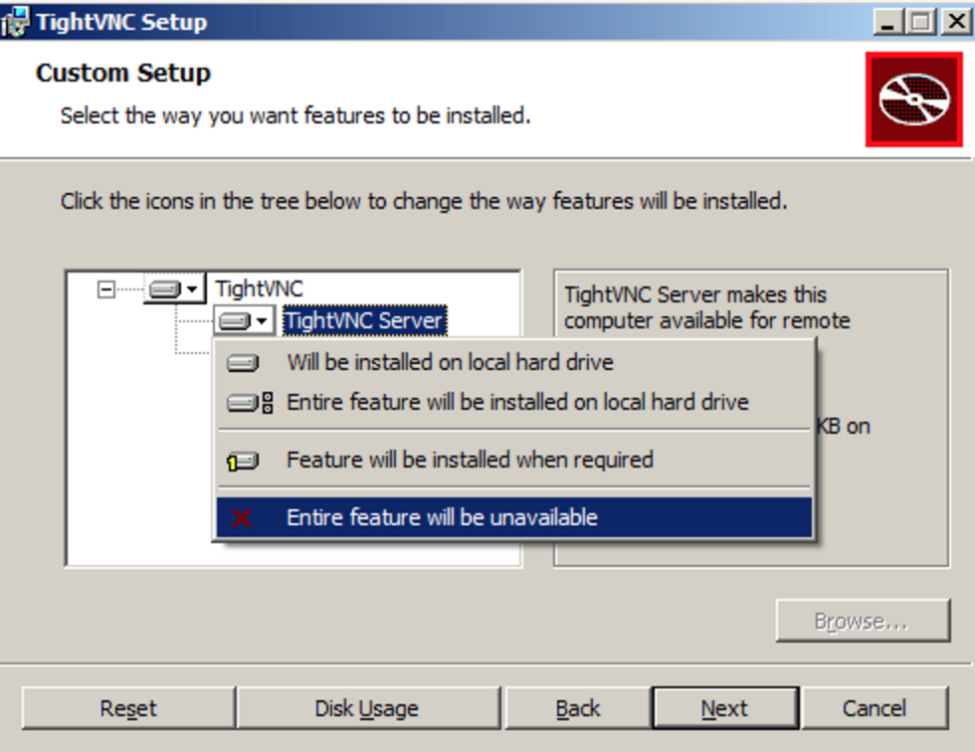

After installation is complete, launch TightVNC Viewer from the Start Menu. At the Remote Host field, enter in the IP address or host name of the HAWK module as the VNC Server. For the demonstration, enter the HAWK’s IP address is 10.10.1.1:1 or host name HAWK-01:1 (the “:1” following the IP address and host name is the VNC screen being accessed). Click on the Connect button and enter the VNC password.

The following steps will ensure VNC starts every time the HAWK module is powered on.

1. Move to the /usr/bin/ directory (type “cd /usr/bin/” and press enter).
2. The following step will create a simple file to start an instance of VNC based on a set configuration. Type “sudo nano vnc.sh”
3. As shown in the figure below, enter the following:

#! /bin/sh

vncserver :1 –geometry 1200x800 –depth 24 –dpi 96

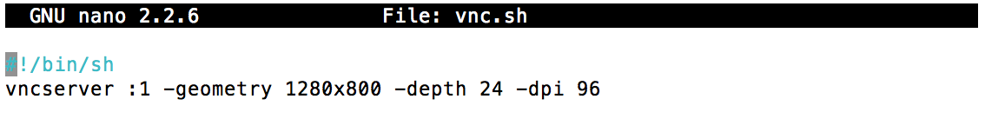

1. After the text is entered, press Control-X, type “y” to save, and then enter again to save the changes using the same file name (vnc.sh).
2. At the prompt, type “chmod +x vnc.sh” and then enter. This will make the vnc.sh file an executable. To test, type “./vnc.sh” and launch the VNC client to test.
3. With the vnc.sh setup as an executable file, the following steps will make this file start every time the HAWK powers up. Type “sudo su” to login as root.
4. Move to /etc/init.d/ directory (type “cd /etc/init.d/’ and press enter).
5. Type “sudo nano vncboot” and press enter.
6. Enter the following into the vncboot file:

#! /bin/sh

# /etc/init.d/vncboot

### BEGIN INIT INFO

# Provides: vncboot

# Required-Start: $remote_fs $syslog

# Required-Stop: $remote_fs $syslog

# Default-Start: 2 3 4 5

# Default-Stop: 0 1 6

# Short-Description: Start VNC Server at boot time

# Description: Start VNC Server at boot time.

### END INIT INFO

USER=BluJay

HOME=/home/BluJay

export USER HOME

case "$1" in

start)

echo "Starting VNC Server"

#Insert your favoured settings for a VNC session

su - BluJay -c "/usr/bin/vncserver :1 -geometry 1280x800 -depth 16 -pixelformat rgb565"

;;

stop)

echo "Stopping VNC Server"

/usr/bin/vncserver -kill :1

;;

*)

echo "Usage: /etc/init.d/vncboot {start|stop}"

exit 1

;;

esac

exit 0

1. After the text is entered, press Control-X, type “y” to save, and then enter again to save the changes using the same file name (vncboot).
2. Type “chmod 755 vncboot” and press enter to make this file an executable.
3. Type “update-rc-d vncboot defaults” and press enter.
4. Reboot the HAWK module (type “reboot” and enter). Once the HAWK module powers up, start a VNC client session with another computer that is on the same network.

Rather than using an IP address to SSH or VNC to the HAWK, Avahi Daemon was installed to enable the use of the module’s domain name. For example, an user can SSH to the HAWK by typing “ssh [BluJay@HAWK-01.local](mailto:BluJay@HAWK-01.local)” or VNC by typing “HAWK-01.local.”

Avahi Daemon was installed from the command line by typing “sudo apt-get install avahi-daemon.” Remote access to the HAWK is now based on the hostname of the module. The host name is shown following the “@” sign at the command line. For example, BluJay@**HAWK-01**. Note, remote access by domain name is always followed by “.local.”

## GPS

Using Adafruit’s Ultimate GPS board, there are two ways to pull GPS data; USB-to-TTL (Serial) or UART (universal asynchronous receiver/transmitter).

**Serial**: Connect the USB-TTL cable to the following pins on the GPS board;

|  |  |
| --- | --- |
| USB-TTL Cable | GPS Board |
| Red | VIN |
| Black | GND |
| Green | RX |
| White | TX |

Plug the USB to the SoC and confirm connection from the Terminal line. To do this, type “ls /dev/ttyUSB*.” The Terminal should return something like “/dev/ttyUSB0.” The “0” maybe different if there is another USB-TTY adapter in use on the SoC.

To see if the GPS module is receiving any data, type “sudo cat /dev/ttyUSB0” and press enter. A series of raw GPS data will appear. Press control-C to return back to the command prompt.

A GPS daemon (gpsd) will need to be installed to convert the raw GPS data into a readable format. With Internet access on the SoC, type “sudo apt-get install gpsd gpsd-clients python-gps” and press enter.

After installation is completed, the gpsd will need to be directed where the GPS data is coming from (in this case, USB0). First, type “dpkg-reconfigure gpsd” and press enter. After this process is completed, type “sudo nano /etc/default/gpsd” and press enter. Review this file and make sure the following are set:

START_DAEMON=”true”

USBAUTO=”true”

DEVICES=””

GPSD_OPTIONS=”/dev/ttyUSB0”

GPSD_SOCKET=”/var/run/gpsd.sock”

To run gpsd, type “cgps –s” and press enter. The Terminal will display GPS data as shown below:

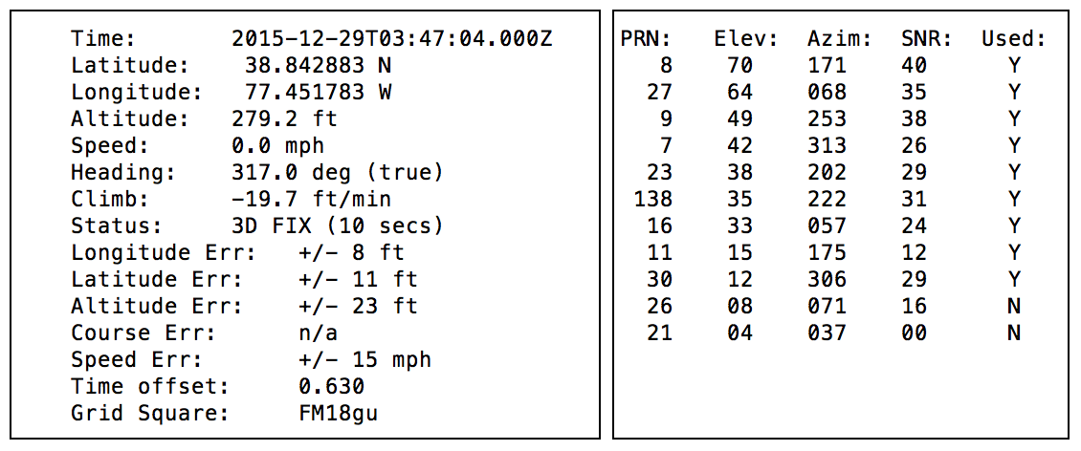

**UART**: Setting up the GPS board to communicate via UART will be similar to that of the USB-TTL procedure above. To begin, we need to enable UART on the SoC. Open a Terminal window and type “sudo raspi-config.” From the menu, go to Advanced Options and then Serial. Highlight “No” and press enter. Reboot the SoC.

Connect the GPS board pins to the SoC GPIO ports as follows;

|  |  |
| --- | --- |
| GPS Board | SoC GPIO |
| VIN | Pin 4 (5V Power) |
| GND | Pin 6 (Ground) |
| RX | Pin 8 (GPIO 14 UART0_TXD) |
| TX | Pin 10 (GPIO 15 UART0_RXD) |

To confirm connection from the Terminal line, type “ls /dev/ttyAMA*.” The Terminal should return something like “/dev/ttyAMA0.”

To see if the GPS module is receiving any data, type “sudo cat /dev/ttyAMA0” and press enter. A series of raw GPS data will appear. Press control-C to return back to the command prompt.

A GPS daemon (gpsd) will need to be installed to convert the raw GPS data into a readable format. With Internet access on the SoC, type “sudo apt-get install gpsd gpsd-clients python-gps” and press enter.

After installation is completed, the gpsd will need to be directed where the GPS data is coming from (in this case, AMA0). First, type “dpkg-reconfigure gpsd” and press enter. After this process is completed, type “sudo nano /etc/default/gpsd” and press enter. Review this file and make sure the following are set:

START_DAEMON=”true”

USBAUTO=”true”

DEVICES=””

GPSD_OPTIONS=”/dev/ttyAMA0”

GPSD_SOCKET=”/var/run/gpsd.sock”

To run gpsd, type “cgps –s” and press enter to see the GPS data.

## Smart Power Switch

**Physical connections**

* On the switch PCB you will notice that the two leads are labeled "in" and "out."
* Connect the “in” lead to GPIO 21 and the “out” lead to GPIO 20 on the SoC. If you would like to use different pins then simply change the pin in the script as explained at bottom of page.
* Connect your original Raspberry Pi power source/micro-USB cable into the micro-USB port on the switch.
* Connect the power source to the SoC.
* Press the power button on the switch PCB and wait for your SoC to boot.

**SOLDERING YOUR OWN SWITCH**

If you purchased one of the circuits without a switch then you can easily attach your own switch as follows:

Solder one end of your switch to the pad labeled "SW+" and the other to the pad labeled "SW-" If you have an additional button you'd like to use as a hard-reset button then you can wire the leads of that switch to "RST+" and "RST-".

The circuit will auto-detect whether you are using a momentary switch or a discrete on-off switch

**Script setup**

*You can use either keyboard input or SSH to install the script for the switch*

If you have a keyboard connected to your Pi then you can type the instructions listed below into the command line and there is no need to use SSH. The Pi must have internet access during installation (but not needed after) for setup.

**Installing the script**

For RaspBMC/Raspbian/Debian distributions (Xbian as well, omit the word sudo), type the following and hit enter after each line:

1. sudo wget http://files.mausberrycircuits.com/setup.sh

2. sudo bash setup.sh

3. sudo reboot

After the Raspberry Pi has fully rebooted, your switch is now ready for use!

**To use a different GPIO pin:**

RaspBMC/Raspbian/Debian:

1. sudo nano /etc/switch.sh

At the top of the script you can change "GPIOpin1=20" and "GPIOpin2=21" to the pins of your choice as numbered in the header diagram above.

The white button on the rocker-switch circuits is a reset button - if for some reason the switch is not functioning as it should, put the rocker switch in the "off" position and press the reset button.

You can perform a hard-reset with the LED switch by holding for 5 seconds.

Please power down the Raspberry Pi prior to doing this (via SSH/remote/keyboard/mouse) as it will perform a hard reset if the Pi is still on.

# Aesthetics

## Change Raspbian Menu Icon

Follow the steps below if you want to change the Raspberry Pi icon on the Menu button (the button at the top left corner when you're logged onto the desktop). The replacement icon should be 36x36 pixels and less than 1.5kb. The original menu icon name is raspitr.png and can be found at /usr/share/raspberrypi-artwork.

1. Right-click a blank space on the taskbar
2. Select "Panel Settings"
3. Switch to the "Panel Applets" tab
4. On that tab, click Menu (should be the second item from the top), then click the Preferences button
5. In the window that pops up, click Browse, navigate to your image, click Close on that window and the Panel Preferences window.

For the demonstration, the menu icon was replaced with Hawk_Icon.png. This icon was placed on the HAWK module via SFTP in the following directory: /home/BluJay/Pictures/

## Change Raspbian Desktop Graphic

Follow the steps below if you want to change the Raspberry Pi graphic on the desktop. The original desktop graphic name is raspberry-pi-logo.png and can be found at /usr/share/raspberrypi-artwork.

1. Right click on the desktop and select Desktop Preferences
2. On the Appearance tab, click on the Wallpaper menu button.
3. A window will appear to allow you to select the replacement desktop graphic. Navigate through the directory to locate and select the new graphic and then click Open.
4. Make any other adjustments as needed

For the demonstration, the desktop graphic was replaced with Hawk Logo 01.png. This graphic was placed on the HAWK module via SFTP in the following directory: /home/BluJay/Pictures/

After the graphic was placed, the wallpaper mode was set to Center unscaled image on the monitor. The background color was set to; Hue 0, Saturation 0, Red 255, Green 255, Blue 255, Color name #FFFFFF

## Banner Login

The banner after logging into the HAWK module (via SSH) was changed to:

\\\\\\\Authorized Use Only///////

The information on this device and network is the property

of Project BluJay and is protected by intellectual property rights.

You must be assigned an account on this device to access information

and are only allowed to access information defined by the system

administrators.

Your activities will be monitored and recorded.

The banner was changed by editing the “motd” file located at “/etc/motd.” To make this change, type “sudo nano /etc/motd” and press enter. After the above text is entered, press Control-X and press “y” to save the changes. Then, press enter again to save the changes under the same file name.

# Cloning SD Card

Due to the sensitivity of the flash memory, it is a good idea to have a “clone” copy of a working SD card for the HAWK module. A clone copy of the SD card will save a great amount of time of rebuilding the HAWK module if the software should become corrupted. This section will go over the steps to clone a SD card based on three different OS; Linux, Mac, and Windows.

**Linux**: TBD

**Mac**: Insert the SD card into the Mac SD slot and open up a Terminal window. Type “diskutil list” and press enter. As shown in the figure below, this command will show the directory path to the SD card.

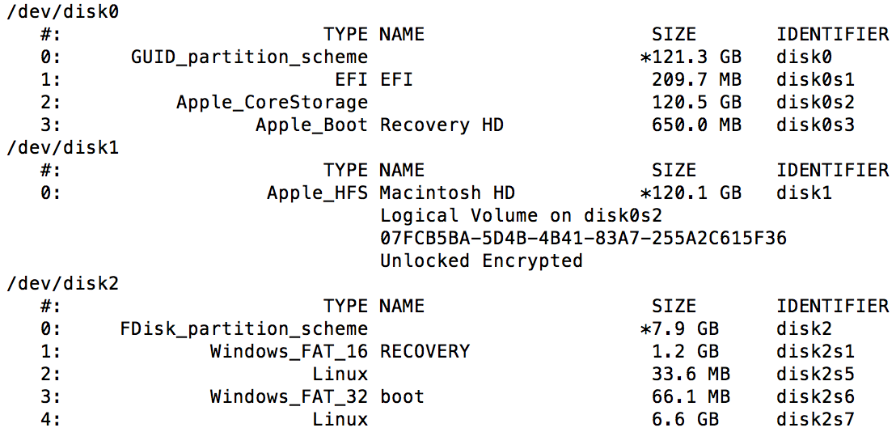

In the example above, the SD card is located under /dev/disk2 (using the “Linux” reference as a clue). Locate and note the directory path of a suitable location where the clone image shall be place. Next, type the following to begin the cloning process:

sudo dd if=/dev/rdisk2 of=/*directory_path*/backup_file_name.img bs=1m

sudo dd if=/Users/armstrongtran/Documents/BluJay/HAWK/SD/sd_backup_01122016.img of=/dev/rdisk2 bs=1m

Based on the “directorypath” above, the clone image of the SD card will be place in that directory under the file name “backup.img.”

To restore or copy the image to another SD card; insert the SD card onto the computer and type “diskutil list” to confirm the SD directory path. Using the previous example, type “disktutil unmountDisk /dev/disk2” and press enter. Similar to step to clone the SD, switch around the directory path for the if (input file) and of (output file). For example:

sudo dd if=/*directory_path*/backup_file_name.img of=/dev/rdisk2 bs=1m

**Windows**: Download and use Win32 Disk Imager application.

(source: <http://raspberrypi.stackexchange.com/questions/311/how-do-i-backup-my-raspberry-pi)>